What is Kafka?

Kafka, licensed by Apache, is an open-source distributed stream-processing platform that is capable of handling more than trillions of events in a day. This massive platform has been developed by **LinkedIn** Team, written in Java and Scala, and donated to the Apache.

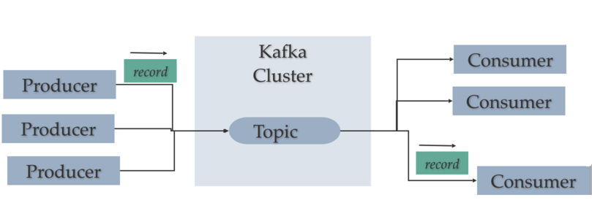

**Chapter 1 - What do you need on your development computer?**

* JDK 1.8 https://www.oracle.com/in/java/technologies/javase-downloads.html

Please check the version of JDK. Prompt> Java -version

* Single node Kafka cluster (Download Kafka 2.12-2.2.0 from [here](http://kafka.apache.org/downloads.html).)

Download the Kafka single cluster by using the following link.

*http://kafka.apache.org/downloads*

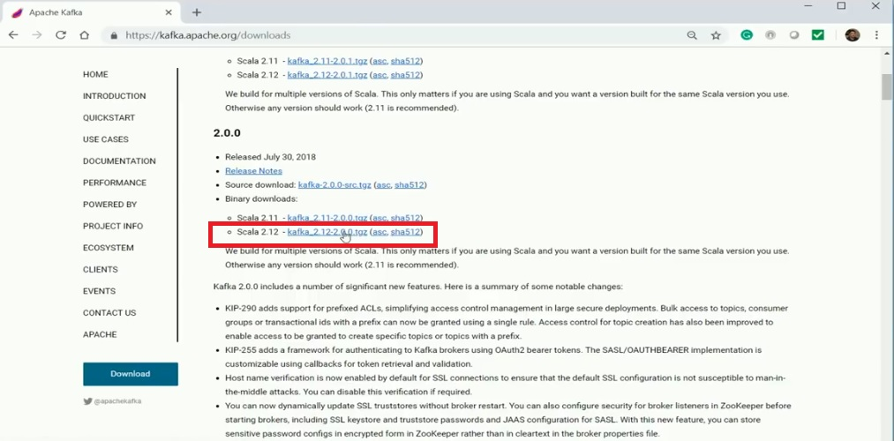

**Configure the Zookeeper Properties**

After downloading the Kafka single cluster, extract the folder and put it into your local drive. In here, we need to configure the Zookeeper. Zookeeper is basically used to manage the Kafka cluster and provides synchronization within distributed systems.

* Create a **New folder** into the *Kafka* folder with the name of zookeeper to keep the file log.

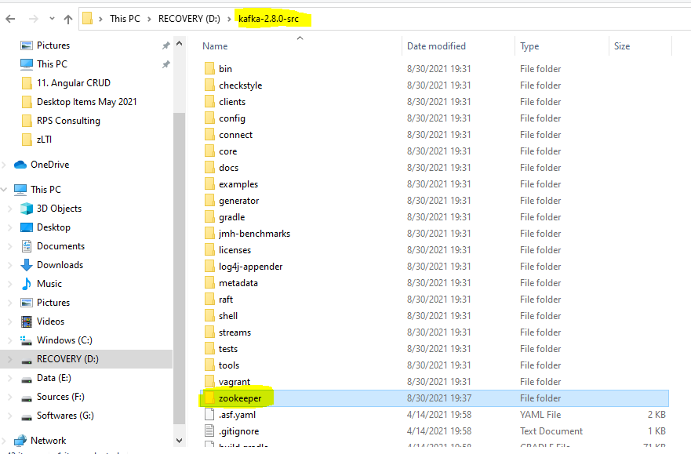

* Go to your Kafka ***config*** directory. For me it’s ***D:\kafka-2.8.0-src\config***

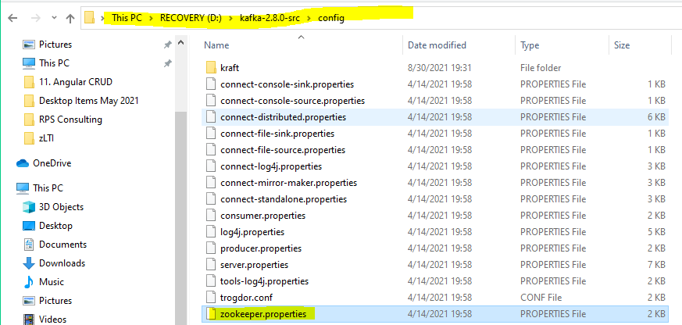

* *Edit the****zookeeper.properties***file and change the following line,

**dataDir=D:\kafka-2.8.0-src\zookeeper**

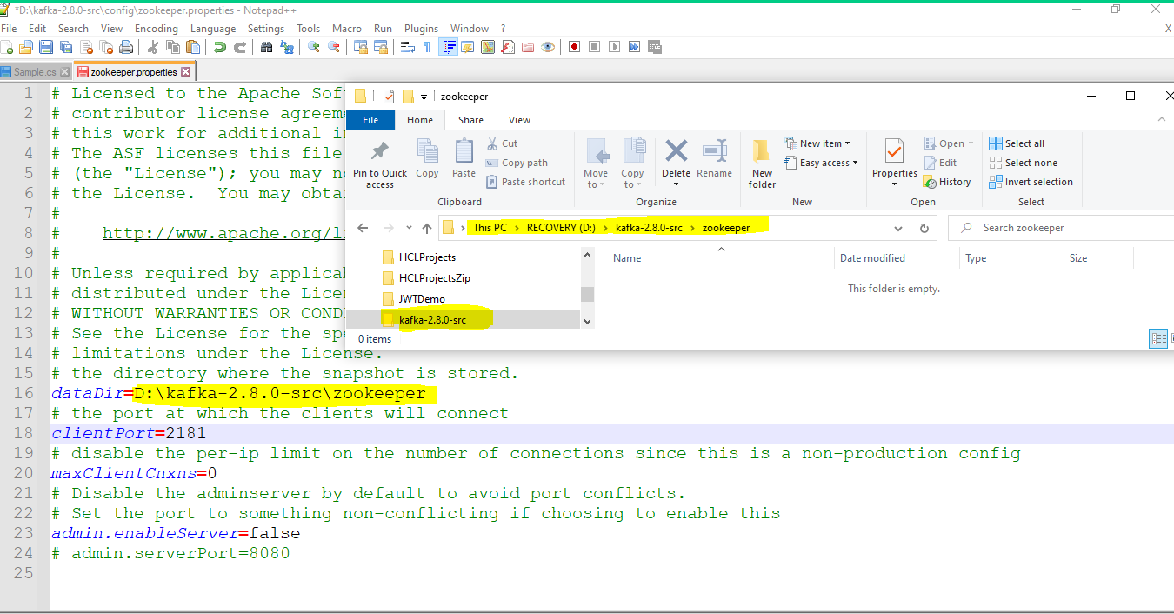

**Configure the Kafka Server Properties**

* Create a **New folder** into the ***Kafka* folder** with the name of *kafka_log* to keep the log file.

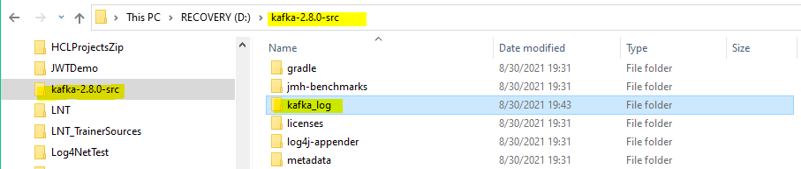

* Go to your Kafka *config* directory. For me it’s ***D:\kafka-2.8.0-src\config****,*

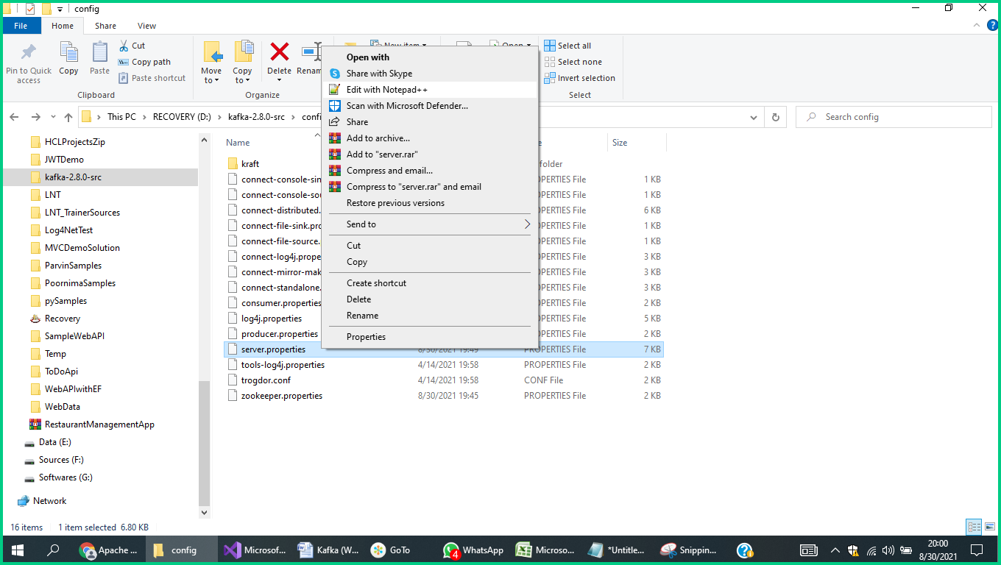

* *Edit the server.properties*file and change the following lines

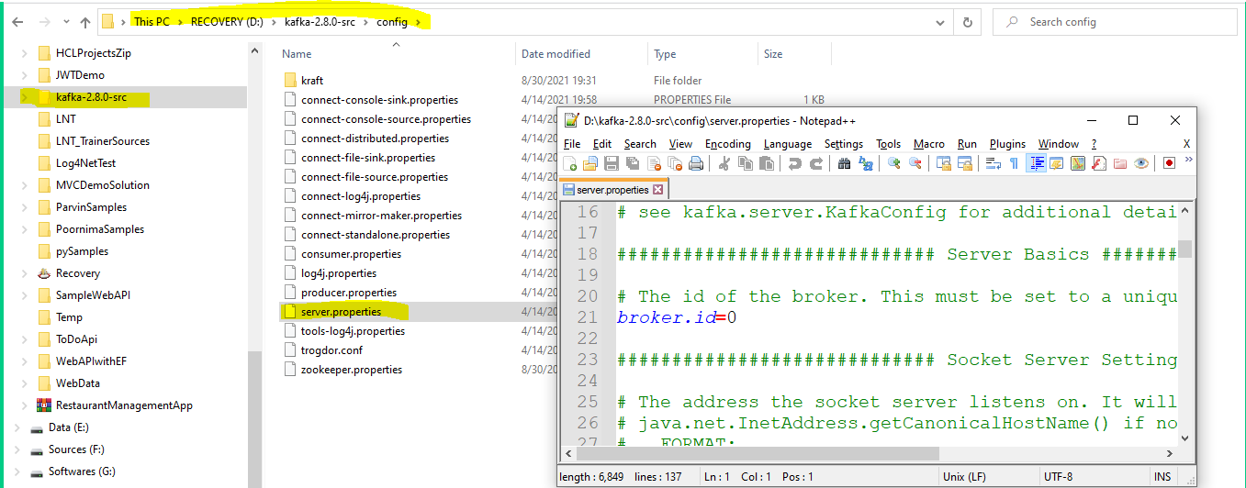

In “**Log Basics**” section

**log.dirs**=**D:\Kafka\kafka_2.12-2.2.0\kafka_log**

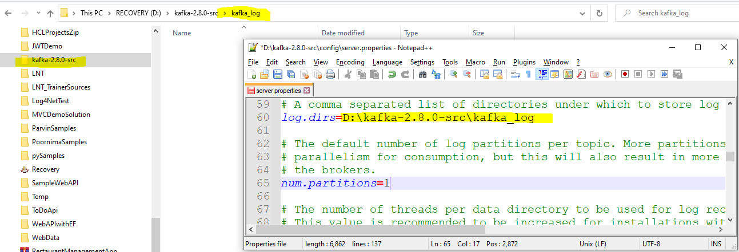

In **“Internal Topic Settings”** Section

**offsets.topic.num.partitions=1**

**offsets.topic.replication.factor=1**

**transaction.state.log.replication.factor=1**

**transaction.state.log.min.isr=1**

**min.inaync.replicas=1**

**default.replication.factor=1**

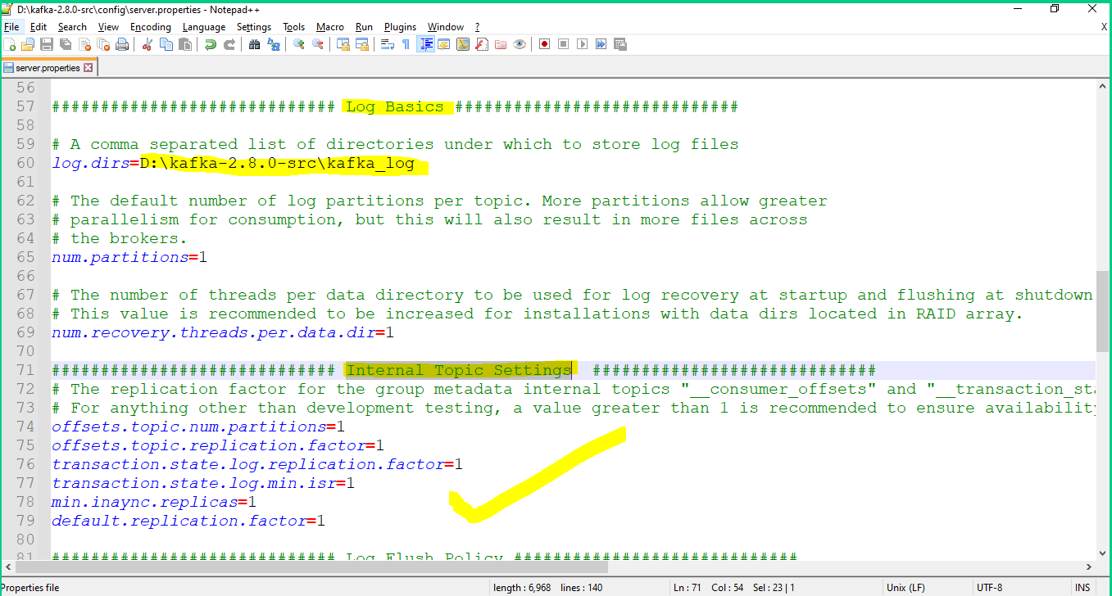

**Chapter 2 - How to start ZooKeeper and Kafka Server**

You need to make sure your ZooKeeper instance is up and running before starting the Kafka server.

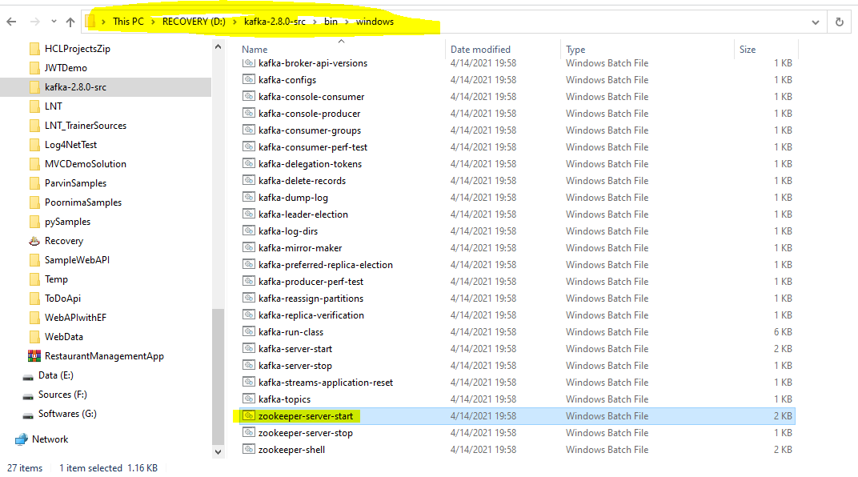

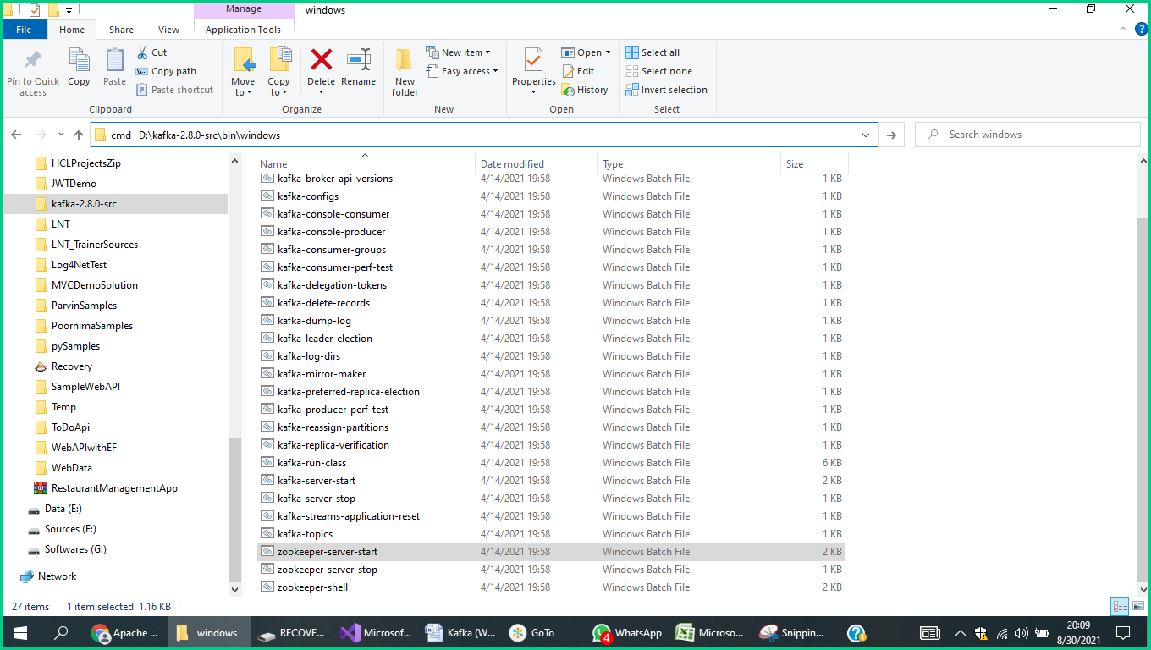

You will get the prompt of **D:\kafka-2.8.0-src\bin\windows>** there you issue the following command

**D:\kafka-2.8.0-src\bin\windows>zookeeper-server-start D:\kafka-2.8.0-src\config\zookeeper.properties**

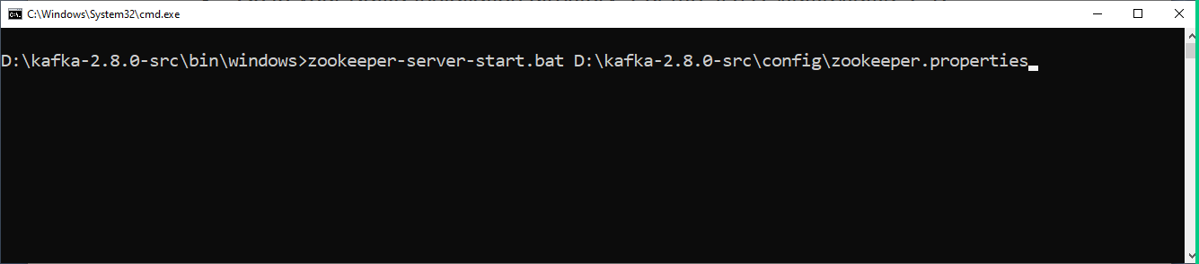

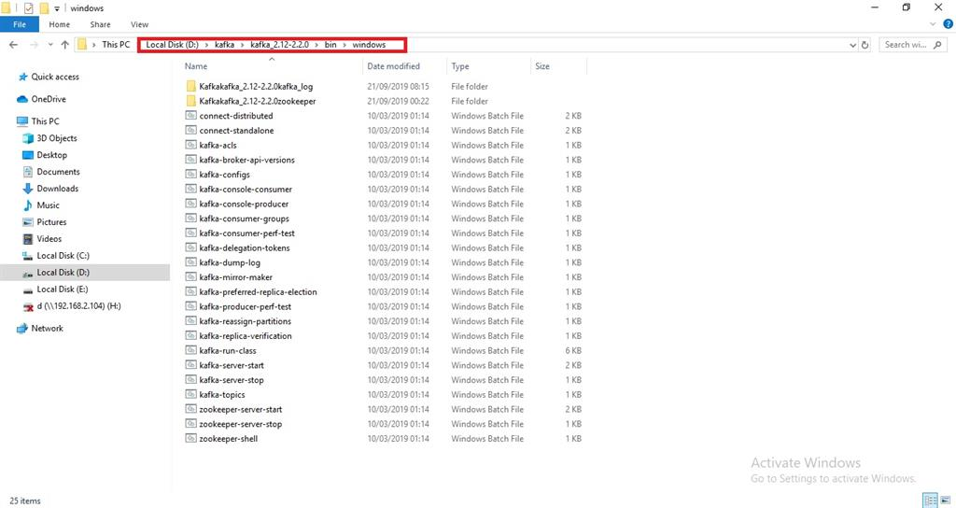

* Go to your Kafka installation directory: *For me, it’s D:\kafka\kafka_2.12-2.2.0\bin\windows*

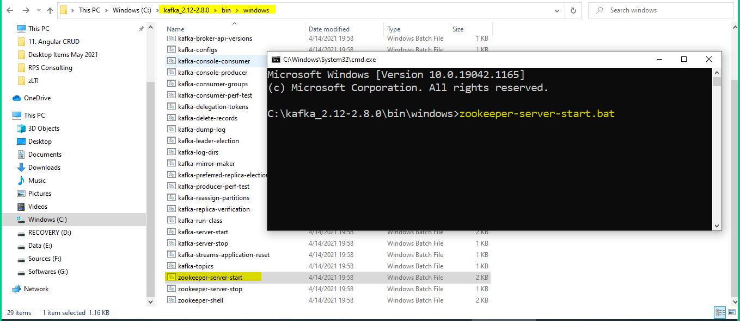

Open a command prompt and run the following command,

**C:\kafka_2.12-2.8.0\bin\windows>**zookeeper-server-start.bat **C:\kafka_2.12-2.8.0\config\zookeeper.properties**

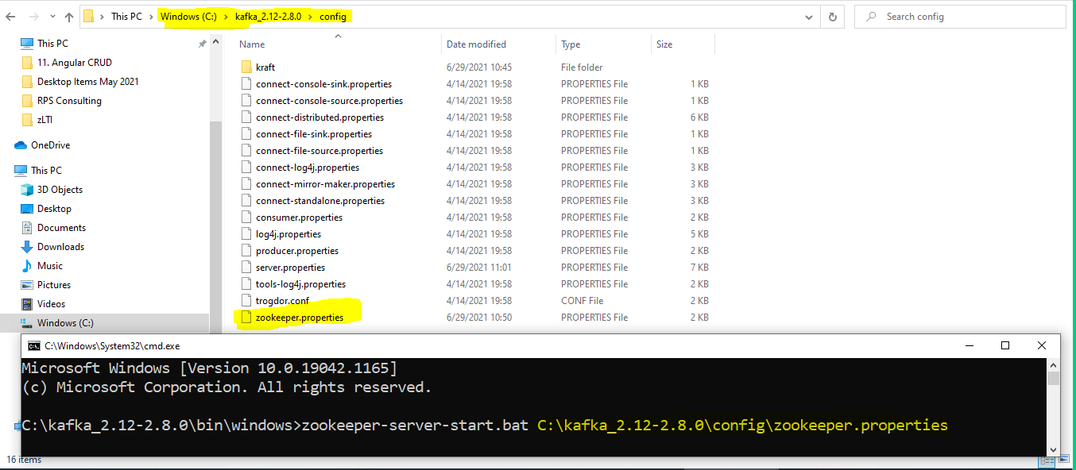

After running the zookeeper follow the below steps.

Go to your **Kafka\bin\windows** folder: *For me, it’s C:\kafka_2.12-2.8.0\bin\windows*

Open a command prompt

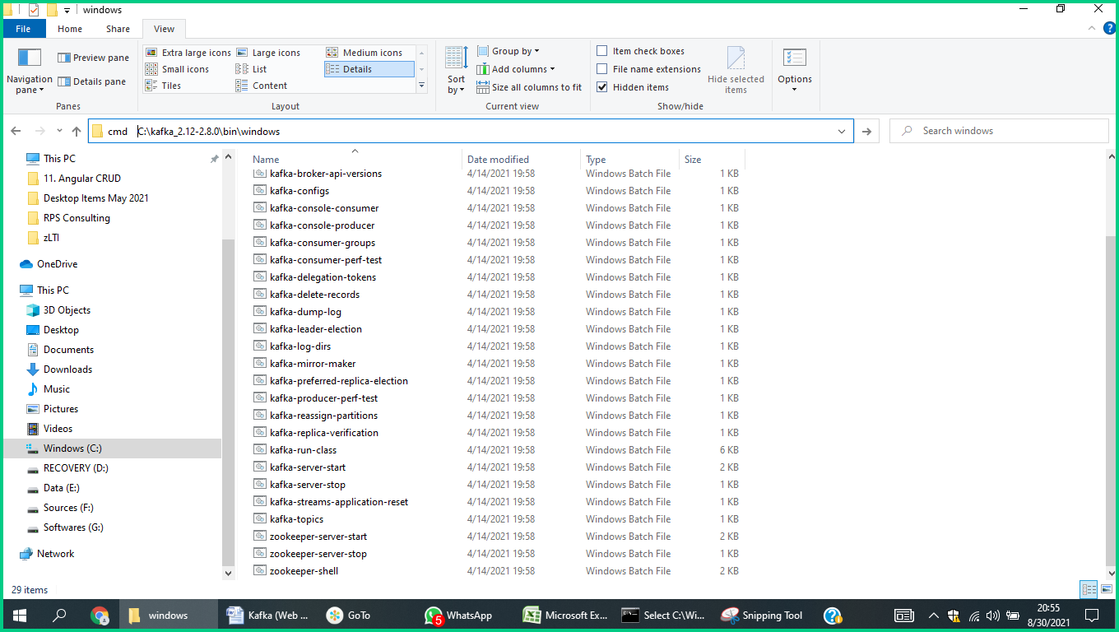

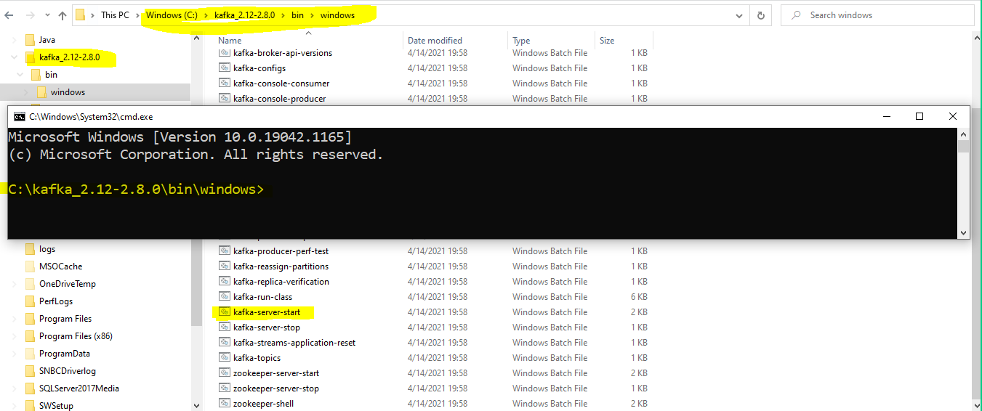

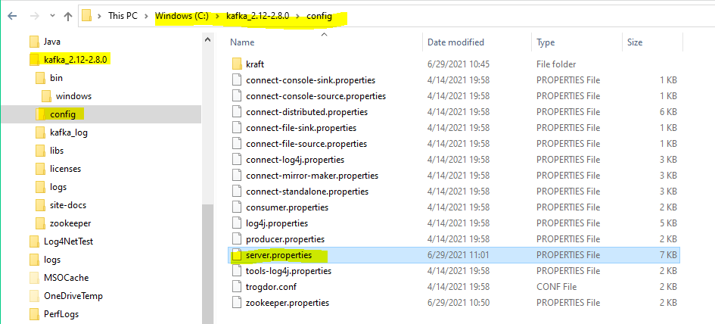

Run the following command,

C:\kafka_2.12-2.8.0\bin\windows>kafka-server-start.bat C:\kafka_2.12-2.8.0\config\server.properties

as follows

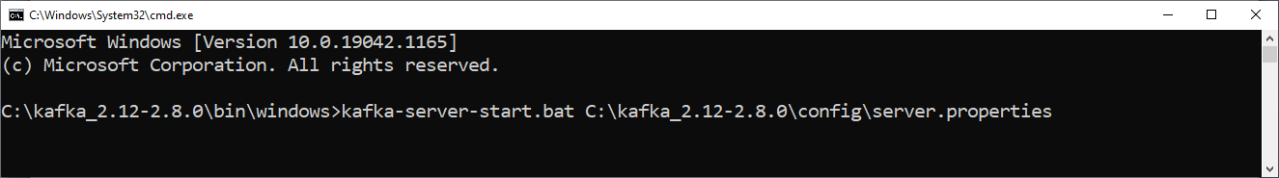

**Creating Topics**

The Kafka topic has been divided into the number of partitions; you can say it is an anatomy of Kafka. It is the most essential part of this distributed messaging system. Topic should have a name to understand the purpose of the message that is stored and published into the server.

Now the time to create a topic with the name of *“chat-message”*. We are running it into only one Kafka server.

* Go to your Kafka installation directory: *For me, it’s* ***C:\kafka_2.12-2.8.0\bin\windows***
* Open a command prompt and run the following command,

kafka-topics.bat --create --zookeeper localhost:2181 -replication-factor 1 --partitions 1 --topic dotnet-training

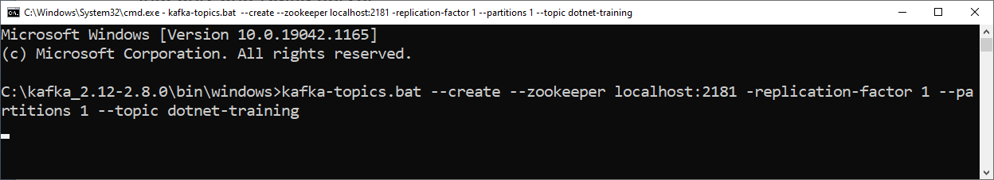

**Creating a Producer and Consumer the Topic from the Kafka Server**

First of all, we need to consume the topic from the server, so for that follow the below steps

* Go to your Kafka installation directory: *For me, it’s D:\kafka\kafka_2.12-2.2.0\bin\windows*
* Open a command prompt and run the following command,

kafka-console-consumer.bat --bootstrap-server localhost:9092 --topic dotnettraining --from-beginning

After consuming the topic we need to produce the message by the following command.

kafka-console-producer.bat --broker-list localhost:9092 --topic dotnettraining

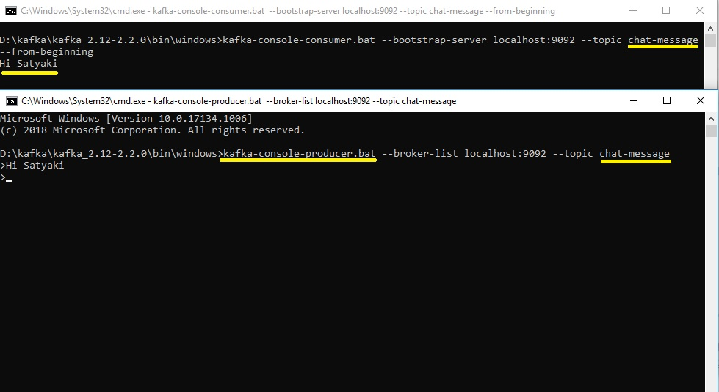

In here, the message is coming from the Kafka server through the chat-message topic and in the second window, we can see the message that we have produced through the Kafka server.

**Additional Explanation**

